**Referring HCP Outreach Letter Template**

Dear [Referring Practice or Physician Name],

I hope this message finds you well. As a [Specialty] practicing in [Community], I wanted to

reach out and make you aware of an exciting solution offered by our practice for the treatment of chronic rhinitis.

By targeting the overactive nasal nerves that cause symptoms such as persistent runny nose, congestion, and postnasal drip, the NEUROMARK® system treats patients with chronic rhinitis at the source in a single gentle outpatient procedure.

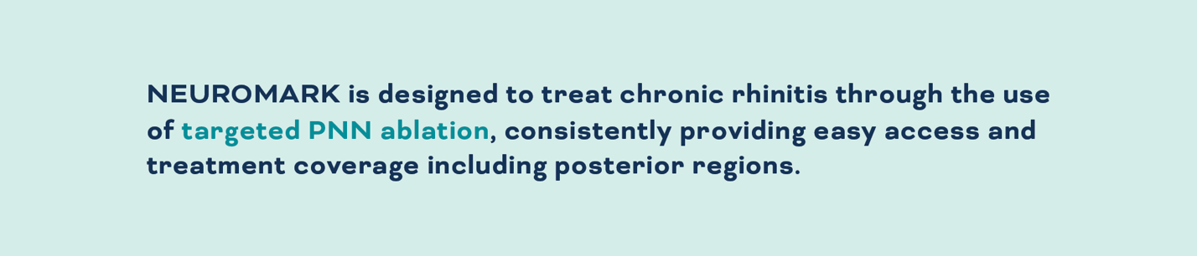

**CLARITY CLINICAL STUDY RESULTS:* 3 MONTHS (N=36)**

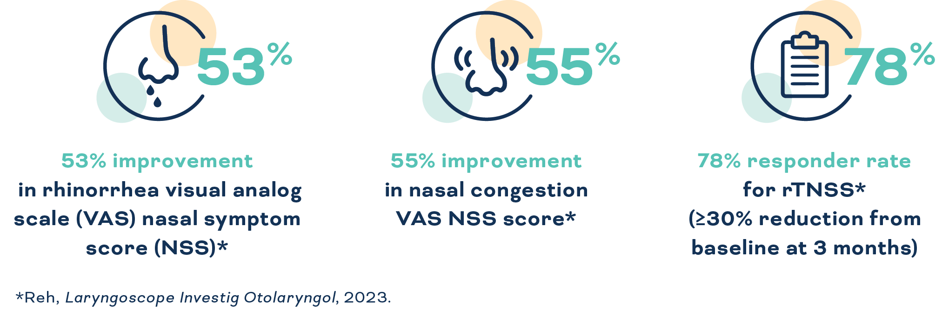

The NEUROMARK procedure is a safe and effective treatment that provides clinically meaningful improvements in symptoms and quality of life.*

*Reh, Laryngoscope Investig Otolaryngol, 2023.

**Accessibility & Convenience**

* May be covered by insurance
* Quick and comfortable in-office procedure
* Symptom reduction observed within **3 months**

**I would like to extend an invitation to refer any patients to us who may be experiencing moderate to severe chronic rhinitis.**

Utilizing NEUROMARK, our practices can collaborate to develop a customized treatment plan to optimize patient outcomes and ensure the best possible care.

Thank you for your attention, and please don't hesitate to reach out if you have any questions.

Warm regards,

[Physician & Practice Name]  
[Contact Information]

**References**

1. Reh, DD, Lay KL, Davis G, et al. Clinical evaluation of a novel multipoint radiofrequency ablation device to treat chronic rhinitis. *Laryngoscope Investig Otolaryngol*. 2023. Published online 16 March 2023:DOI: 10.1002/lio2.1040.