**Patient Outreach Letter Template**



Dear [Patient Name],

As a patient with chronic rhinitis (CR) in our practice, it’s important that you are aware of a treatment option that has been shown to be effective in relieving symptoms.

**Meet NEUROMARK®**

NEUROMARK targets symptoms like persistent runny nose, congestion, and postnasal drip at the source, disrupting the overactive nerves that cause CR and delivering proven results. The procedure is available as a quick, in-office procedure and may be covered by some insurance plans.

A recent study shows that after NEUROMARK procedure, patients experienced a significant reduction in nasal congestion, runny nose, nasal itching, and sneezing.

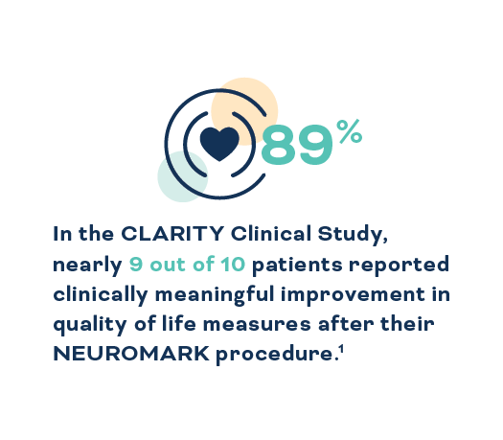 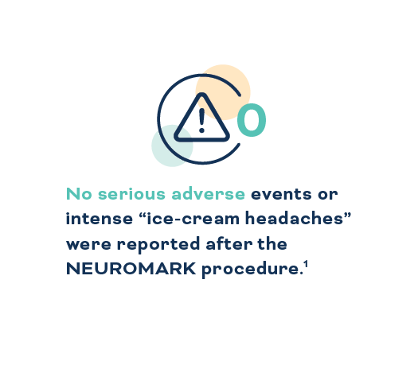

**Ready to ditch the tissues?**

If NEUROMARK sounds like the treatment option you’ve been searching for, schedule an appointment with our office TODAY to discuss NEUROMARK in greater depth.

[Insert link to make a virtual appointment]

**Click here to schedule an appointment >**

I hope to see you soon so we can discuss this exciting

opportunity for treatment.

Warm regards,

[Physician & Practice Name]

[Contact Information]

**References**

1. Reh, DD, Lay KL, Davis G, et al. Clinical evaluation of a novel multipoint radiofrequency ablation device to treat chronic rhinitis. *Laryngoscope Investig Otolaryngol*. 2023. Published online 16 March 2023:DOI: 10.1002/lio2.1040.